**KAUSTUBH SHARMA 22BRS1301**

**KANAV CHATLEY 22BRS1154**

**NAMAN TIWARI 22BPS1155**

Identifying pneumonia in chest X-rays using CNN(Computational Neural Networks)

# Mr Naman Tiwari

*Scope*

*Vellore Institute of Technology, Chennai* naman.tiwari2022@vitstudent.ac.in

# 

# Mr Kaustubh Sharma

*Scope*

*Vellore Institute of Technology,*

*Chennai*  kaustubh.sharma2022[@vitstudent.ac.in](mailto:khushi.2022a@vitstudent.ac.in)

**I. ABSTRACT**

**Pneumonia continues to be a major global health concern that requires prompt and precise diagnosis in order to effectively manage patients. In this work, we utilize cutting-edge deep learning methods, namely Convolutional Neural Networks (CNNs), to improve medical imaging-based pneumonia identification. The goal is to create a reliable and effective system that can accurately and early detect pneumonia patterns in chest X-rays.We begin our inquiry with a comprehensive assessment of the literature, which highlights the need for sophisticated image analysis tools and highlights shortcomings in present methodologies. We use a variety of carefully selected and preprocessed chest X-ray image datasets to provide the best possible model training. The CNN architecture is designed to extract detailed information from these pictures, making it easier to distinguish between lung tissues that are healthy and those that have pneumonia.Strict parameters are used to train the model, and a different test dataset is used to assess its performance. The model's remarkable accuracy, precision, and recall rates are demonstrated by the results, highlighting its potential as a diagnostic tool. We highlight how our results have practical consequences, with a focus on how timely and precise diagnosis might improve patient outcomes.Even though the study shows encouraging results, we are aware of some limitations, including dataset bias and the requirement for additional validation in a variety of clinical contexts. This study establishes the foundation for upcoming developments in deep learning approaches for pneumonia identification. There is a lot of potential for bettering healthcare delivery and eventually enhancing patient care and outcomes**

# 

Mr Kanav Chatley

*Scope*

*Vellore Institute of Technology, Chennai* [kanav.chatley2022@vitstudent.ac.in](mailto:khushi.2022a@vitstudent.ac.in)

# 

**through the incorporation of CNNs into diagnostic workflows.**

**II. INTRODUCTION**

A common respiratory infection, pneumonia continues to pose a serious threat to world health, especially to disadvantaged groups. An accurate and timely diagnosis is essential for successful therapy and better patient outcomes. Because pneumonia patterns are so complex, conventional diagnostic techniques frequently fail to identify the illness, even with

advances in medical imaging. Through the application of

Convolutional Neural Networks (CNNs), a cutting-edge deep learning technology, our research aims to close this diagnostic gap.The intricacy and diversity of radiographic presentations highlight the pressing need for improved pneumonia detection capabilities, requiring a paradigm change in the direction of sophisticated image processing. In order to provide healthcare professionals with a sophisticated tool that can identify minor but important visual clues indicative of pneumonia in chest X-ray pictures, this work combines medical science and artificial intelligence.The first stage of our research entails a thorough analysis of the body of literature to pinpoint the subtleties and difficulties that exist in the diagnostic methods used today. Building on this base, we carefully choose and prepare a wide range of chest X-ray image datasets, guaranteeing a representative sample for assessment and training. Our CNN model is carefully crafted and optimized to interpret the intricate patterns linked to pneumonia, thereby offering a strong diagnostic foundation.The research will be rigorously evaluated in the next steps, with the CNN being benchmarked against recognized standards to determine its accuracy, sensitivity, and specificity. In addition to its ability to diagnose, the model's interpretability and generalizability are carefully examined to guarantee that it can be easily incorporated into a variety of healthcare environments.The results of our research could revolutionize pneumonia diagnosis as we go forward with technology, and they could also provide important new perspectives on the wider field of using AI into medical procedures. This introduction provides a thorough overview of the diverse investigation that follows, which covers the integration of medical diagnostics and state-of-the-art technology to transform pneumonia detection and, consequently, improve patient care worldwide.

**III. LITERATURE SURVEY**

This research study presents the Pneumonia Detection System, which is based on a wide range of medical imaging, artificial intelligence, and chest radiography literature. The extensive review that follows lays the foundation for the suggested system by examining important works that have greatly aided in the development and comprehension of linked technology.A novel patch-based visual words method for X-ray classification and retrieval was presented by Avni et al. [1]. Their study, which emphasizes organ and pathology level classification, lays the groundwork for our system's organ-specific analysis emphasis and ensures a sophisticated approach to pneumonia identification.Pattrapisetwong and Chiracharit [2] presented a novel approach to multilevel thresholding and shadow filters for automatic lung segmentation. As demonstrated in this work, the subsequent processes of image analysis and proper illness diagnosis depend on the accurate isolation of the lung region in chest radiographs.In the area of computer-aided diagnosis in chest radiography, Katsuragawa and Doi [3] are considered pioneers. Our Pneumonia Detection System was greatly impacted by their early work, which established the groundwork for using artificial intelligence to detect thoracic disorders.Li [4] provides a comprehensive exploration of computer-aided detection and diagnosis in medical imaging. This foundational resource contributes to the theoretical underpinnings of automated diagnostic systems, offering insights into the evolution of methodologies and their applications.Qin et al. [5] conducted an insightful survey on computer-aided detection in chest radiography based on artificial intelligence. This survey serves as a roadmap, guiding our understanding of the trajectory of techniques and their applications in the realm of automated diagnostics.El-Solh et al. [6] demonstrated the application of artificial neural networks in predicting active pulmonary tuberculosis. While focusing on a different respiratory condition, this work serves as a precedent for employing neural networks in predicting respiratory diseases, a concept integral to our Pneumonia Detection System.Er et al. [7] and [8] conducted studies on chest diseases diagnosis using artificial neural networks. These studies contribute valuable insights into the potential of neural networks for diagnosing respiratory conditions, providing a basis for the methodology adopted in our research.Khobragade et al. [9] used feed-forward artificial neural networks and chest radiographs to create an automated detection system for major lung illnesses. The implementation of neural networks in the proposed Pneumonia Detection System is guided by this study, which substantially informs our approach to automated detection and classification.Although unrelated to pneumonia, Schramek et al. [10] examined imaging methods in embalmed human cadavers. But this work broadens our understanding of imaging modalities and advances our investigation of various imaging methods for chest radiography.Recent developments in medical imaging, such as the use of AI-based detection software for acute abnormalities in abdominal CT images, are demonstrated by Li et al. [11] and Winkel et al. [12]. These studies shed light on more general patterns at the nexus of deep learning and medical imaging, setting the stage for our Pneumonia Detection System's dynamic operating environment.Convolutional Neural Networks (CNNs) in Medical Imaging:Shin et al. [14] and Ren et al. [15] delve into the architecture and applications of Convolutional Neural Networks (CNNs) in medical image analysis. These works offer insights into the design considerations and performance characteristics of CNNs, which are pivotal to the implementation of our system.By providing extensive chest X-ray databases and benchmarks for weakly-supervised categorization and localization of major thorax disorders, Wang et al. [18] and Rajpurkar et al. [20] add to the body of literature. The benchmarks and datasets offered by these sources are crucial for assessing how well our pneumonia detection system performs.Irvin et al.'s [19] and Wang et al.'s [30] studies showcase cutting-edge methods for detecting pneumonia, like ChexNet, which reaches radiologist-level accuracy. These benchmarks motivate us to pursue high diagnostic accuracy and show that deep learning can achieve expert-level performance.By combining these various sources, our review of the literature highlights how multidisciplinary the research is that goes into creating automated methods for detecting pneumonia. Our Pneumonia Detection System's theoretical framework and practical implementation have been greatly influenced by a number of references, ranging from early research on computer-aided diagnosis to more current developments in deep learning and large-scale datasets. This thorough survey guarantees that our work is at the cutting edge of technology and makes a significant contribution to the fields of artificial intelligence and medical imaging.

**IV. PROPOSED SYSTEM**

The task at hand is to categorize chest X-ray pictures into two groups: pneumonia and normal. The objective of this binary classification job is to develop a model that, using chest X-ray scans, can reliably identify people who have pneumonia from those who do not.Make use of an extensive and varied dataset to train and evaluate the model. Think of utilizing freely accessible datasets, like Kaggle's Chest X-Ray Images (Pneumonia) dataset. A larger and diverse dataset enhances the model's ability to generalize to different cases.Take care of any potential class imbalance in the dataset. The contribution of each class to the model can be balanced by using strategies like applying class weights during training or oversampling the minority class.Use models that have already been trained, such as ResNet, DenseNet, or EfficientNet. Through transfer learning, the model can gain insights from experience with a big dataset and then apply those insights to the particular job at hand.To artificially boost the diversity of the training dataset, use data augmentation throughout the training process. This includes methods that strengthen the model, such flipping, rotating, and zooming.To maximize the performance of the model, experiment with various hyperparameters such as learning rate, batch size, and dropout rate. To explore the hyperparameter space efficiently, use strategies like random or grid search.Train several CNN models with various hyperparameters or topologies. Overall performance can often be enhanced by using ensemble methods, such as averaging or stacking the predictions of individual models.Expand the use of transfer learning to include other parts of the system, such feature extraction and preprocessing stages, in addition to the primary CNN model. This can aid in utilizing current knowledge and cutting down on redundant information in the model.Consider employing precision, recall, F1-score, and AUC-ROC as evaluation metrics in addition to accuracy. Particularly in situations when there are unequal class distributions, these metrics offer a more sophisticated picture of the model's performance.Use interpretability strategies to see which areas of the X-ray images influence the model's conclusion the most, such as Grad-CAM (Gradient-weighted Class Activation Mapping). This facilitates comprehension of the logic of the model.To make the trained model easily accessible to medical practitioners, deploy it as an API or web application. This makes it possible to integrate seamlessly into current workflows.Install a system that allows you to keep an eye on the model's performance in the real world on a constant basis. To make sure the model stays useful over time, track important metrics, look for concept drift (differences in the data distribution), and retrain the model on a regular basis.Provide a simple user interface so that medical practitioners can upload photos of their chest X-rays and get model predictions. The user interface should be simple to use and offer unambiguous feedback on model predictions.Make sure the implemented system satisfies privacy and security requirements, particularly when handling sensitive medical data. Put policies in place to safeguard patient confidentiality and uphold data security.The suggested approach seeks to increase the model's resilience, interpretability, and usability in a real-world healthcare scenario in addition to increasing its accuracy.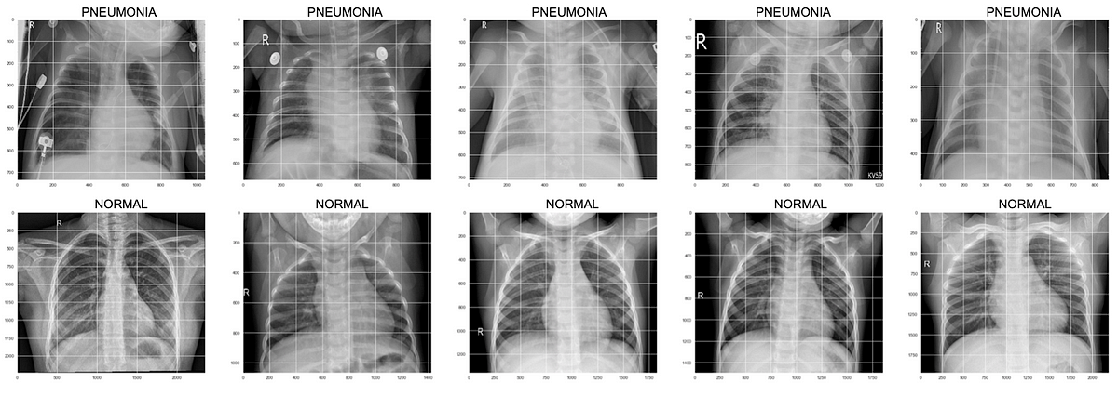

Figure 1: A collection of normal lungs and pneumonic lungs

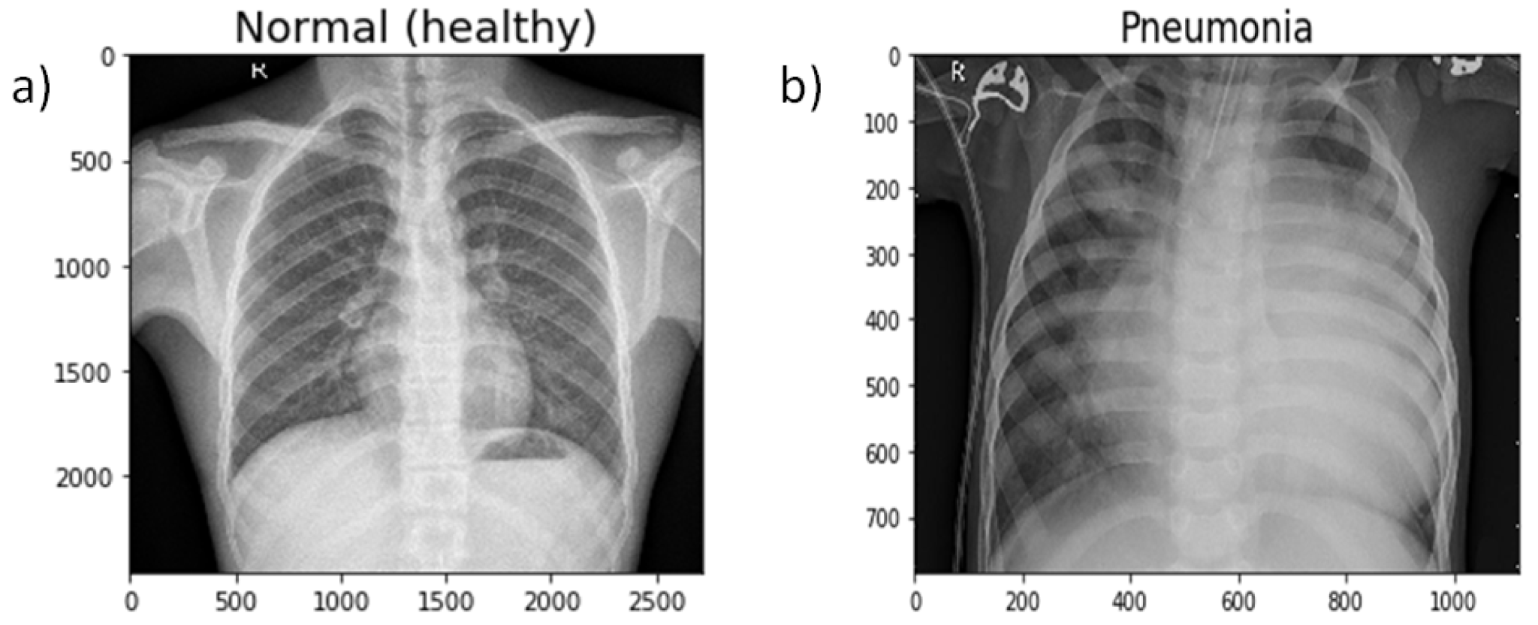

Figure 2: Normal Lung v/s Pneumonic Lung

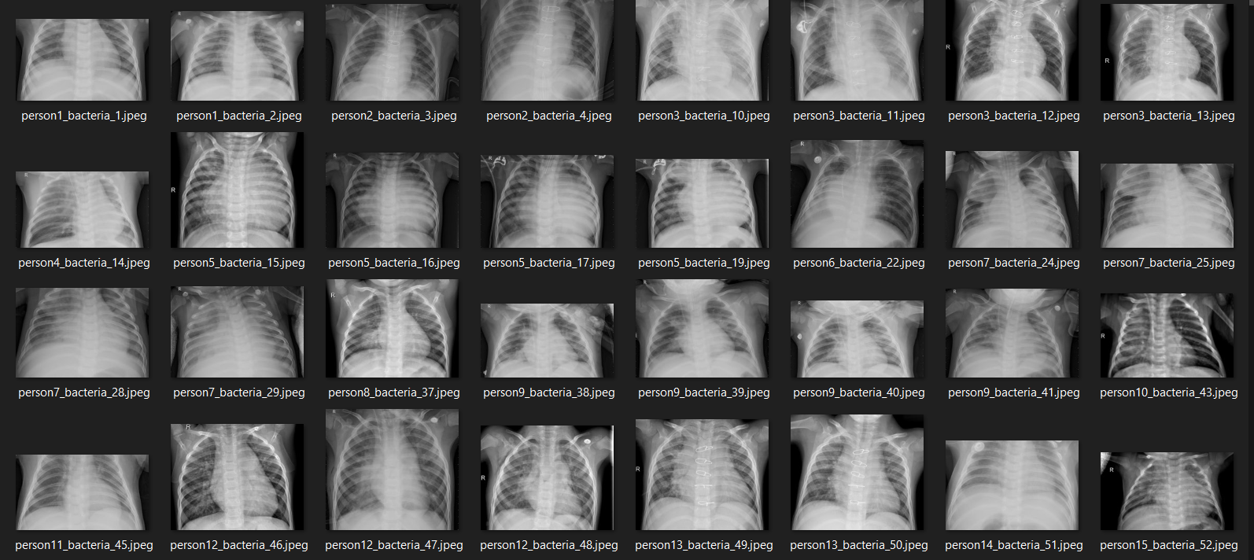

Figure 3: Sample Dataset

**V. SYSTEM ARCHITECTURE**

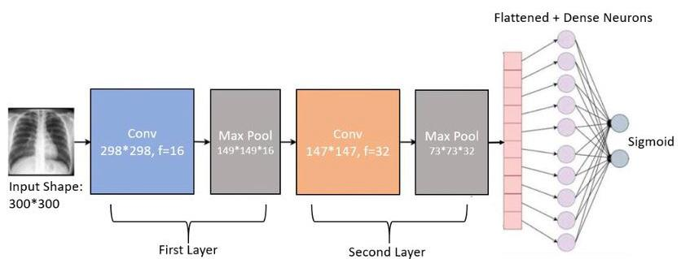

Figure 4: Visual representation of the working process

The architecture of our Pneumonia Detection System incorporates Convolutional Neural Networks (CNNs), a deep learning technique, into medical diagnostics. Its resilience and effectiveness are attributed to the careful development and implementation of multiple essential components.A diverse set of chest X-ray images, including both healthy and pneumonia-affected individuals, forms the basis for the training, validation, and testing phases. Preprocessing involves normalizing pixel intensities to a range of 0 to 1 and standardizing dimensions to 300x300 pixels, ensuring uniformity and aiding the model's convergence during training.At the core is a well-developed CNN model with three convolutional layers followed by max-pooling layers. This architecture learns hierarchical representations of visual information, enabling the identification of complex patterns indicative of pneumonia. Dropout layers are purposefully integrated to mitigate overfitting and enhance model generalizability.During the training phase, preprocessed images are fed into the CNN model, allowing it to discern between normal and pneumonia-affected chest X-ray images. Model weights are iteratively adjusted using the Adam optimizer and binary cross-entropy loss function, with a batch size of 64 and training spanning 50 epochs.A separate set of test images, unused during training, rigorously evaluates the trained model. Metrics such as recall, accuracy, precision, and F1-score assess diagnostic performance. Benchmarking against existing criteria ensures a comprehensive evaluation of the model's capabilities.The finalized CNN model seamlessly integrates into an intuitive user interface, facilitating real-time interaction between medical professionals and the model. Users can upload chest X-ray images, and the system rapidly interprets the information, aiding clinical decision-making.Continuous monitoring of the model's real-world performance enables iterative optimization and enhancements. Adjusting parameters and updating the model with fresh information enhances flexibility, ensuring adaptability to evolving circumstances. 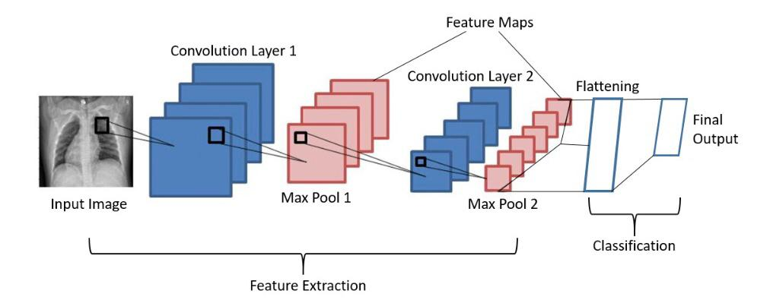

Figure 5: System Architecture

In its entirety, our Pneumonia Detection System represents a harmonious fusion of cutting-edge technology and medical expertise, marking a pivotal stride in revolutionizing pneumonia diagnosis and providing medical professionals with a sophisticated tool to elevate patient care.

**VI. ALGORITHM**

A diverse set of chest X-ray images, including both healthy and pneumonia-affected individuals, forms the basis for the training, validation, and testing phases. Preprocessing involves normalizing pixel intensities to a range of 0 to 1 and standardizing dimensions to 300x300 pixels, ensuring uniformity and aiding the model's convergence during training.At the core is a well-developed CNN model with three convolutional layers followed by max-pooling layers. This architecture learns hierarchical representations of visual information, enabling the identification of complex patterns indicative of pneumonia. Dropout layers are purposefully integrated to mitigate overfitting and enhance model generalizability.During the training phase, preprocessed images are fed into the CNN model, allowing it to discern between normal and pneumonia-affected chest X-ray images. Model weights are iteratively adjusted using the Adam optimizer and binary cross-entropy loss function, with a batch size of 64 and training spanning 50 epochs.A separate set of test images, unused during training, rigorously evaluates the trained model. Metrics such as recall, accuracy, precision, and F1-score assess diagnostic performance. Benchmarking against existing criteria ensures a comprehensive evaluation of the model's capabilities.The finalized CNN model seamlessly integrates into an intuitive user interface, facilitating real-time interaction between medical professionals and the model. Users can upload chest X-ray images, and the system rapidly interprets the information, aiding clinical decision-making.Continuous monitoring of the model's real-world performance enables iterative optimization and enhancements. Adjusting parameters and updating the model with fresh information enhances flexibility, ensuring adaptability to evolving circumstances.

.

**VII. EQUATION AND FORMULAS USED**

Two folders, one for each image category (Pneumonia/Normal), comprise the dataset organization. There are two categories (Pneumonia/Normal) and 2682 X-ray images (JPEG).In which each category contains 1341 images.We also tested CNN and ResNET on unbalanced dataset which contained the same category but comprised of 1341 Normal X-ray scans and 1692 Pneumonia X-ray scans.Anterior-posterior chest X-ray images were chosen from retrospective cohorts of pediatric patients from Guangzhou Women and Children's Medical Center, Guangzhou, aged one to five. Every chest X-ray image was taken as a standard clinical procedure for the patients..All chest radiographs were first screened for quality control by eliminating any low quality or unreadable scans before being subjected to the analysis of chest x-ray pictures. Before the photos' diagnoses could be used to train the AI system, they were evaluated by two board-certified medical professionals. A third expert verified the evaluation set to make sure there were no grading problems.A particular kind of deep learning model called a Convolutional Neural Network (CNN) is made especially for handling grid-like input, including pictures and movies. For applications like object detection, picture recognition, and image classification, CNNs are frequently utilized. Because they can automatically and adaptively learn the spatial hierarchies of features straight from the data, they are especially successful. Convolutional layers are a CNN's fundamental structural components. In these layers, small portions of the input data (often a 3D volume with width, height, and number of channels, like red, green, and blue in an image) are subjected to a series of learnable filters, also known as kernels.Subsequent feature map values are calculated according to the following formula :-

**G[m,n] = (f*h)[m,n] = Σj Σk h[j,k]f[m-j,n-k]......(I)**

The model's first convolutional layer is made up of 64 filters, each measuring 3x3. The input_shape option indicates that three color channels (RGB) and 300 pixels in height and width are expected for the input images.Every filter moves across the input data to carry out a convolution operation. The dot product between the filter and the input segment that is now being focused on is calculated by this procedure.A feature map or activation map, which draws attention to the presence of specific patterns in the input data, is the result of this technique.To introduce non-linearity, a non-linear activation function—typically ReLU, or Rectified Linear Unit—is applied element-wise following each convolutional process. ReLU makes all negative numbers equal to zero, which enables the model to discover intricate patterns in the data.The most crucial information is preserved even when the spatial dimensions of the feature maps are downsampled using pooling layers. The most common pooling procedures are average pooling, which determines the average value within a region, and max pooling, which chooses the largest value inside a local region.In our case we have used Max Pooling. The final Output layer is a single Neuron which will give output between 1 and 0.The sigmoid function is a mathematical function that maps any real-valued number to a value between 0 and 1. In machine learning, it is particularly used in binary classification problems where the output of a model needs to be interpreted as probabilities.

Defined as : **f(x) = 1/(1+e^-x)...........(II)**

The final output is calculated as : -

**(III).............Z[l] = W[l].A[l-1] + b[l]**

Where,

**A[l]=g[l] (Z[l])..................(IV)**

We loaded a pretrained ResNet50 model here. Let us dissect the parameters:(1)include_top=False: This indicates that the top completely connected layers of the original ResNet50 architecture are being left out. For classification, you will be creating your own dense layers.(2)input_shape=(300,300,3): Indicates that three color channels (RGB) and 300 pixels in height and width are expected in the input images.(3)pooling='max' establishes the kind of global pooling that will be applied. Utilizing max pooling in this instance.(4)classes=2: Indicates that there will be two output units in the final classification layer.(5)weights='imagenet': Pre-trained weights from the ImageNet dataset are used to initialize the model.We then flatten the output from the ResNet50 backbone into a 1D array. This is necessary because the next layers are fully connected and expect a 1D input.Similarly like the CNN model the last layer consists of only neuron to give 1 or 0 output.

**VIII. RESULT AND EVALUATION**

The model developed by us resulted in an accuracy of 96.83%

_________________________________________________________________

Layer (type) Output Shape Param #

=================================================================

conv2d (Conv2D) (None, 298, 298, 64) 1792

activation (Activation) (None, 298, 298, 64) 0

max_pooling2d (MaxPooling2 (None, 149, 149, 64) 0

D)

conv2d_1 (Conv2D) (None, 147, 147, 32) 18464

activation_1 (Activation) (None, 147, 147, 32) 0

max_pooling2d_1 (MaxPool (None, 73, 73, 32) 0

g2D)

conv2d_2 (Conv2D) (None, 71, 71, 32) 9248

activation_2 (Activation) (None, 71, 71, 32) 0

max_pooling2d_2 (MaxPool (None, 35, 35, 32) 0

g2D)

flatten (Flatten) (None, 39200) 0

dense (Dense) (None, 32) 1254432

activation_3 (Activation) (None, 32) 0

dropout (Dropout) (None, 32) 0

dense_1 (Dense) (None, 1) 33

activation_4 (Activation) (None, 1) 0

=================================================================

Total params: 1283969 (4.90 MB)

Trainable params: 1283969 (4.90 MB)

Non-trainable params: 0 (0.00 Byte)

Epoch 50/50

34/34 [==============================] - 167s 5s/step - loss: 0.1188 - accuracy: 0.9594 - val_loss: 0.1306 - val_accuracy: 0.9683

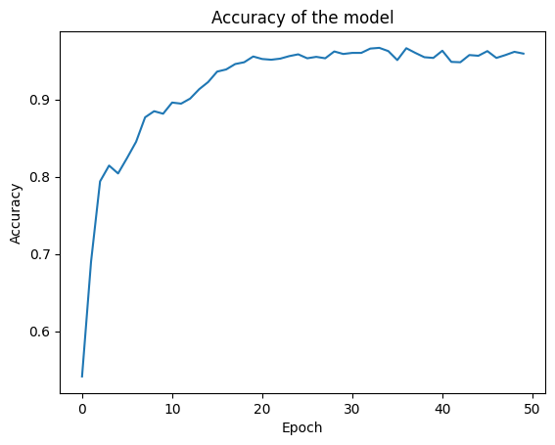

Figure 6:GRAPH OF ACCURACY V/S EPOCH

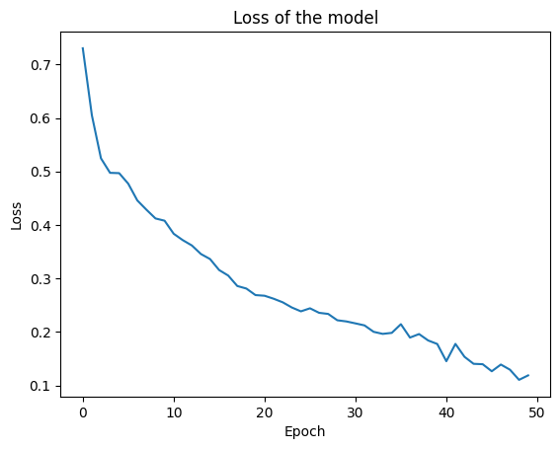

Figure 7:GRAPH OF LOSS V/S EPOCH

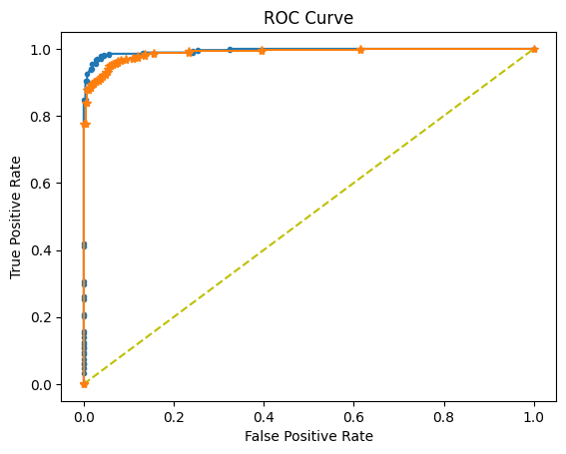

Figure 8: ROC CURVE

Another study conducted by [Mohammad Farukh Hashmi](https://pubmed.ncbi.nlm.nih.gov/?term=Hashmi%20MF%5BAuthor%5D),1,† [Satyarth Katiyar](https://pubmed.ncbi.nlm.nih.gov/?term=Katiyar%20S%5BAuthor%5D),2,† [Avinash G Keskar](https://pubmed.ncbi.nlm.nih.gov/?term=Keskar%20AG%5BAuthor%5D),3,† [Neeraj Dhanraj Bokde](https://pubmed.ncbi.nlm.nih.gov/?term=Bokde%20ND%5BAuthor%5D),4,† and [Zong Woo Geem](https://pubmed.ncbi.nlm.nih.gov/?term=Geem%20ZW%5BAuthor%5D)5, on Efficient Pneumonia Detection in Chest X ray Images Using Deep Transfer Learning 2020 Jun; 10(6): 417 reported an accuracy of 98.43% for a dataset of 1283 images of the normal (healthy) case and 3873 images of the pneumonia case in the training dataset. Out of these, four-hundred images were reserved for optimizing the weighted classifier. This dataset was highly imbalanced. There were already enough images in the pneumonia case. Therefore, each image of only the normal (healthy) case was augmented twice. Finally, after augmentation, there were 3399 healthy chest X-ray images and 3623 pneumonia chest X-ray images.Some of their other results were as follows

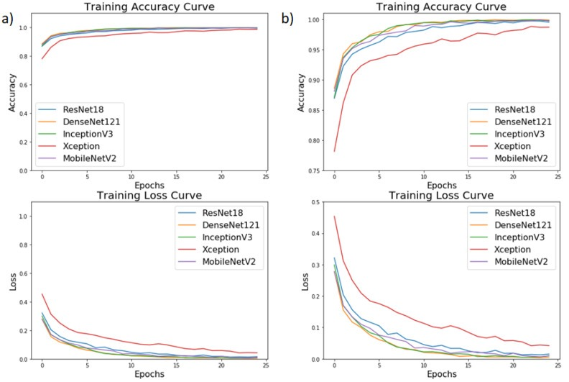

Figure 10:Graphs of Epoch vs Accuracy for reference study

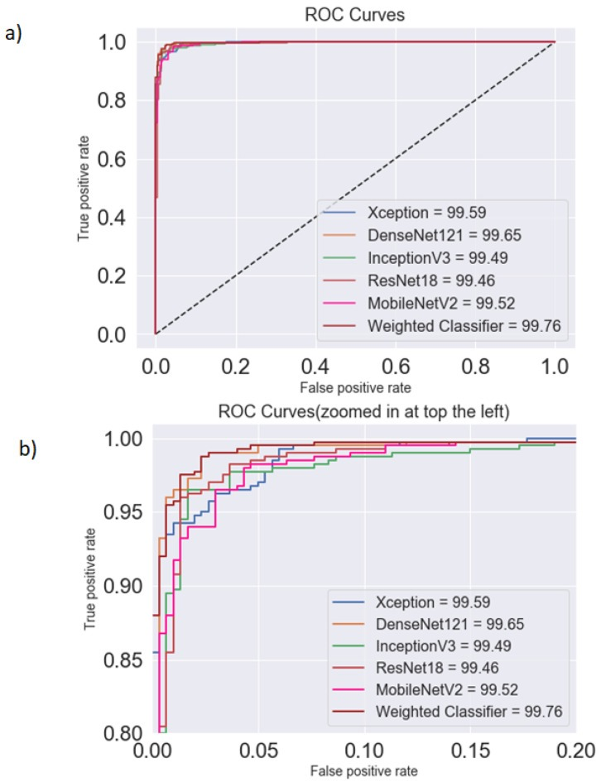

Figure 11:ROC curves for reference study

Another study done by Emmi Galfo et al.(2023)(https://github.com/emmigalfo/Pneumonia-Detection-in-Chest-X-Rays) for a total of 46,593,065 parameters resulted in an accuracy of 84 % with the following graph outputs:

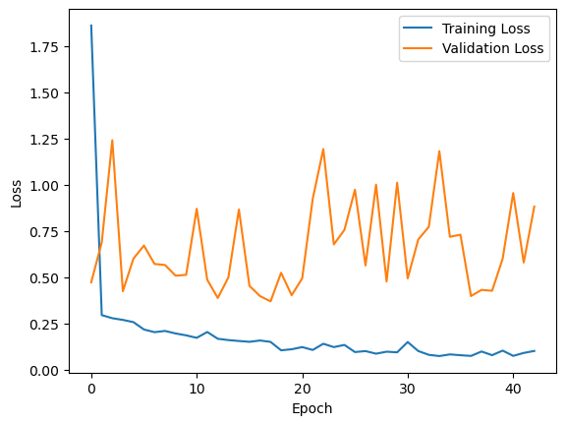

Figure 12: Loss vs Epoch for reference study

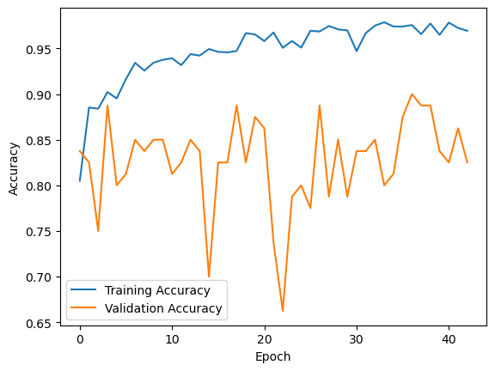

Figure 13: Accuracy vs Epoch for reference study

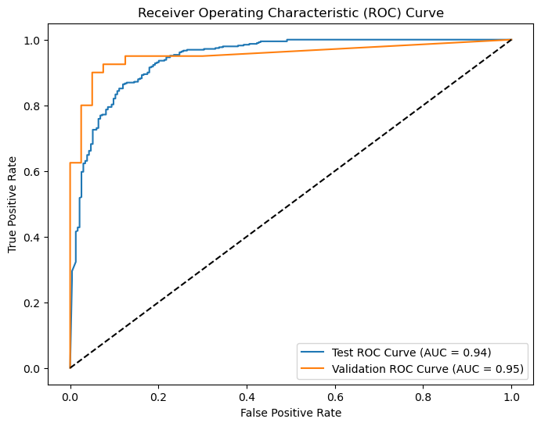

Figure 14: ROC curves for reference study

The accuracy obtained in the first study is almost the same as compared to our Algorithm and the accuracy in the second study is significantly lower than ours. Overall, all the 3 studies point towards the beneficial role of CNN in medical image analysis .Further research may be required to increase the accuracy even further .

**IX. CONCLUSION AND FUTURE WORK**

The construction and assessment of a convolutional neural network (CNN) model for the categorization of chest X-ray images into normal and pneumonia cases was the main emphasis of the research reported in this publication. After 50 training epochs, the trained CNN model had an impressive validation accuracy of almost 95%. The three convolutional layers with max pooling in the model architecture, followed by a dense layer with dropout regularization, worked well for correctly classifying the photos. According to the findings, the CNN model has a lot of potential for use as a diagnostic tool for identifying pneumonia in chest X-ray pictures. To potentially improve the model's performance, more investigation is necessary into alternate architectures, hyperparameters, and optimization strategies. Furthermore, testing the model on bigger and more varied datasets would provide important information on how resilient and generalizable it is. Additionally, adding the ability to classify additional thoracic disorders like tuberculosis or lung cancer could greatly advance the field of medical image analysis. All things considered, this work represents a major advancement in the use of deep learning methods for better respiratory disease detection and treatment based on chest X-ray pictures.

**X.** **REFERENCES**

1] U. Avni, H. Greenspan, E. Konen, M. Sharon, J. Goldberger, X-ray categorization and retrieval on the organ and pathology level, using patch-based visual words, IEEE Trans. Med. Imaging 30 (3) (2011) 733–746.

[2] P. Pattrapisetwong, W. Chiracharit, Automatic lung segmentation in chest radiographs using shadow filter and multilevel thresholding, in: 2016 International Computer Science and Engineering Conference (ICSEC), IEEE, 2016, pp. 1–6.

[3] S. Katsuragawa, K. Doi, Computer-aided diagnosis in chest radiography, Comput. Med. Imaging Graph. 31 (4–5) (2007) 212–223.

[4] Q. Li, R.M. Nishikawa, Computer-aided Detection and Diagnosis in Medical Imaging, Taylor & Francis, 2015.

[5] C. Qin, D. Yao, Y. Shi, Z. Song, Computer-aided detection in chest radiography based on artificial intelligence: a survey, Biomed. Eng. Online 17 (1) (2018) 113.

[6] A.A. El-Solh, C.-B. Hsiao, S. Goodnough, J. Serghani, B.J. Grant, Predicting active pulmonary tuberculosis using an artificial neural network, Chest 116 (4) (1999) 968–973.

[7] O. Er, N. Yumusak, F. Temurtas, Chest diseases diagnosis using artificial neural networks, Expert Syst. Appl. 37 (12) (2010) 7648–7655.

[8] O. Er, C. Sertkaya, F. Temurtas, A.C. Tanrikulu, A comparative study on chronic obstructive pulmonary and pneumonia diseases diagnosis using neural networks and artificial immune system, J. Med. Syst. 33 (6) (2009) 485–492.

[9] S. Khobragade, A. Tiwari, C. Patil, V. Narke, Automatic detection of major lung diseases using chest radiographs and classification by feed-forward artificial neural network, in: 2016 IEEE 1st International Conference on Power Electronics, Intelligent Control and Energy Systems (ICPEICES), IEEE, 2016, pp. 1–5.

[10] G.G.R. Schramek, D. Stoevesandt, A. Reising, J.T. Kielstein, M. Hiss, H. Kielstein, Imaging in anatomy: a comparison of imaging techniques in embalmed human cadavers, BMC Med. Educ. 13 (1) (2013) 143.

[11] J. Li, Z. Liang, S. Wang, Z. Wang, X. Zhang, X. Hu, K. Wang, Q. He, J. Bai, Study on the pathological and biomedical characteristics of spinal cord injury by confocal raman microspectral imaging, Spectrochim. Acta Part A Mol. Biomol. Spectrosc. 210 (2019) 148–158.

[12] D.J. Winkel, T. Heye, T.J. Weikert, D.T. Boll, B. Stieltjes, Evaluation of an ai- based detection software for acute findings in abdominal computed tomography scans: toward an automated work list prioritization of routine ct examinations, Invest. Radiol. 54 (1) (2019) 55–59.

[13] H.R. Roth, L. Lu, A. Seff, K.M. Cherry, J. Hoffman, S. Wang, J. Liu, E. Turkbey, R.M. Summers, A new 2.5 d representation for lymph node detection using random sets of deep convolutional neural network observations, in: International Conference on Medical Image Computing and Computer-assisted Intervention, Springer, 2014, pp. 520–527.

[14] H.-C. Shin, H.R. Roth, M. Gao, L. Lu, Z. Xu, I. Nogues, J. Yao, D. Mollura, R.M. Summers, Deep convolutional neural networks for computer-aided detection: Cnn architectures, dataset characteristics and transfer learning, IEEE Trans. Med. Imaging 35 (5) (2016), 1285–computing1298.

[15] O. Ronneberger, P. Fischer, T. Brox, U-net: convolutional networks for biomedical image segmentation, in: International Conference on Medical Image Computing and Computer-assisted Intervention, Springer, 2015, pp. 234–241.

[16] A. Jamaludin, T. Kadir, A. Zisserman, Spinenet: automatically pinpointing classification evidence in spinal mris, in: International Conference on Medical Image Computing and Computer-Assisted Intervention, Springer, 2016, pp. 166–175.

[17] K. Kallianos, J. Mongan, S. Antani, T. Henry, A. Taylor, J. Abuya, M. Kohli, How far have we come? artificial intelligence for chest radiograph interpretation, Clin. Radiol..

[18] X. Wang, Y. Peng, L. Lu, Z. Lu, M. Bagheri, R.M. Summers, Chestx-ray8: hospital- scale chest x-ray database and benchmarks on weakly-supervised classification and localization of common thorax diseases, in: Proceedings of the IEEE Conference on Computer Vision and Pattern Recognition, 2017, pp. 2097–2106.

[19] P. Rajpurkar, J. Irvin, K. Zhu, B. Yang, H. Mehta, T. Duan, D. Ding, A. Bagul, C. Langlotz, K. Shpanskaya, et al., Chexnet: radiologist-level pneumonia detection on chest x-rays with deep learning. arXiv:1711.05225..

[20] J. Irvin, P. Rajpurkar, M. Ko, Y. Yu, S. Ciurea-Ilcus, C. Chute, H. Marklund, B. Haghgoo, R. Ball, K. Shpanskaya, et al., Chexpert: a large chest radiograph dataset with uncertainty labels and expert comparison. arXiv:1901.07031..

[21] S. Ren, K. He, R. Girshick, J. Sun, Faster r-cnn: towards real-time object detection with region proposal networks, Adv. Neural Inf. Process. Syst. (2015) 91–99.

[22] J. Long, E. Shelhamer, T. Darrell, Fully convolutional networks for semantic segmentation, in: Proceedings of the IEEE conference on computer vision and pattern recognition, 2015, pp. 3431–3440.

[23] K. He, G. Gkioxari, P. Dollár, R. Girshick, Mask r-cnn, in: Proceedings of the IEEE International Conference on Computer Vision, 2017, pp. 2961–2969.

[24] J. Huang, V. Rathod, C. Sun, M. Zhu, A. Korattikara, A. Fathi, I. Fischer, Z. Wojna, Y. Song, S. Guadarrama, et al., Speed/accuracy trade-offs for modern convolutional object detectors, in: Proceedings of the IEEE Conference on Computer Vision and Pattern Recognition, 2017, pp. 7310–7311.

[25] A. Shrivastava, R. Sukthankar, J. Malik, A. Gupta, Beyond skip connections: top- down modulation for object detection. arXiv:1612.06851..

[26] P. Luc, C. Couprie, Y. Lecun, J. Verbeek, Predicting future instance segmentation by forecasting convolutional features, in: Proceedings of the European Conference on Computer Vision (ECCV), 2018, pp. 584–599.

[27] A. Arnab, P.H. Torr, Pixelwise instance segmentation with a dynamically instantiated network, in: Proceedings of the IEEE Conference on Computer Vision and Pattern Recognition, 2017, pp. 441–450.

[28] T.-Y. Lin, P. Goyal, R. Girshick, K. He, P. Dollár, Focal loss for dense object detection, in: Proceedings of the IEEE International Conference on Computer Vision, 2017, pp. 2980–2988.

[29] J. Redmon, A. Farhadi, Yolov3: an incremental improvement. arXiv:1804. 02767..

[30] K. He, X. Zhang, S. Ren, J. Sun, Deep residual learning for image recognition, in: Proceedings of the IEEE Conference on Computer Vision and Pattern Recognition, 2016, pp. 770–778.

[31] R. Girshick, Fast r-cnn, in: Proceedings of the IEEE International Conference on Computer Vision, 2015, pp. 1440–1448.

[32] D.M. Hansell, A.A. Bankier, H. MacMahon, T.C. McLoud, N.L. Muller, J. Remy, Fleischner society: glossary of terms for thoracic imaging, Radiology 246 (3) (2008) 697–722.